**Adf-orchestration**

This document details the design and implementation of an enterprise-grade **orchestration framework** built using **Azure Data Factory (ADF)**. The framework serves as the central nervous system for coordinating and managing complex data pipelines across multiple Azure services and on-premises systems. It provides a standardized approach to workflow management, error handling, monitoring, and dependency management for all data engineering workflows within the organization.

The solution replaces fragmented, standalone scripts with a unified orchestration layer that ensures reliability, maintainability, and scalability of data operations.

**2. Objectives**

The primary objectives of this orchestration framework are:

* **Centralized Workflow Management:** To provide a single pane of glass for managing, scheduling, and monitoring all data pipeline executions.
* **Robust Error Handling & Retry Mechanisms:** To implement comprehensive failure management with configurable retry policies, logging, and alerting.
* **Dependency Management:** To establish clear execution sequences and handle dependencies between different data processing activities and pipelines.
* **Operational Excellence:** To reduce manual intervention through automation while providing detailed operational logs for troubleshooting and auditing.
* **Scalability & Reusability:** To design modular pipeline components that can be reused across different business scenarios and can scale with growing data volumes.

**3. Technology Stack**

| Category | Technology / Service | Justification |
| --- | --- | --- |
| **Orchestration** | **Azure Data Factory** | Primary orchestration service for workflow scheduling, execution, and monitoring. |
| **Compute** | **Azure Databricks** | Spark-based processing for complex data transformations. |
|  | **Azure Synapse Analytics** | Cloud data warehouse for large-scale data processing and serving. |
| **Storage** | **Azure Data Lake Gen2** | Primary storage layer for raw and processed data. |
| **Monitoring** | **Azure Monitor & Log Analytics** | Centralized logging, monitoring, and alerting. |
| **Security** | **Azure Key Vault** | Secure management of secrets and connection strings. |
| **Infrastructure** | **Azure DevOps** | CI/CD for ADF pipeline deployment and version control. |

**4. System Architecture & Design**

**4.1. High-Level Architecture**

The orchestration framework follows a modular, hub-and-spoke design with clear separation of concerns between orchestration, processing, and storage layers.

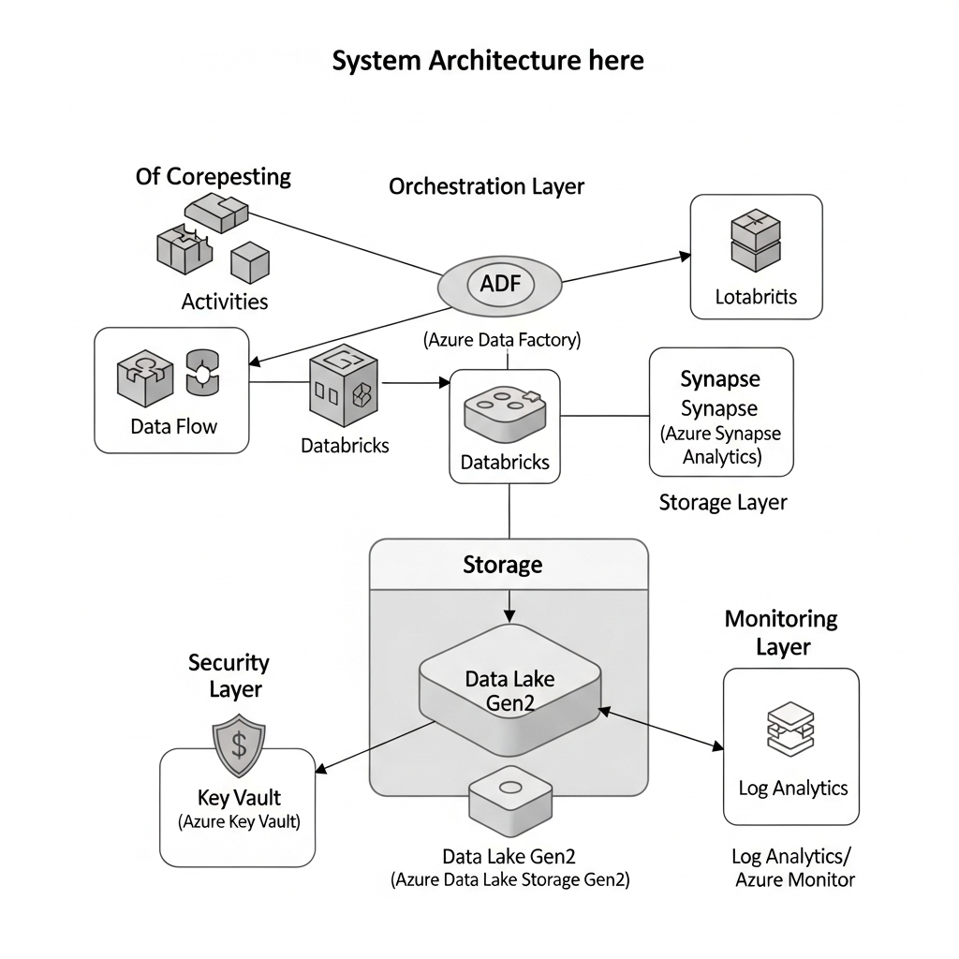

**4.2. Orchestration Patterns Implemented**

**4.2.1. Master Pipeline Pattern**

A central master pipeline (PL_Master_Orchestration) coordinates the execution of multiple child pipelines in a specific sequence with dependency handling.

**4.2.2. Event-Driven Execution**

Pipelines can be triggered by various events including:

* Schedule triggers (for batch processing)
* Blob storage events (for file arrival)
* Custom events via Webhooks
* Manual triggers for ad-hoc executions

**4.2.3. Fan-Out/Fan-In Pattern**

Parallel execution of independent tasks (fan-out) followed by synchronization and aggregation of results (fan-in).

**5. Implementation**

**5.1. Pipeline Structure & Components**

**5.1.1. Linked Services & Integration Runtime**

* All connection configurations stored as Linked Services
* Azure Integration Runtime configured for optimal performance
* All secrets and credentials managed through Azure Key Vault

**5.1.2. Master Orchestration Pipeline**

The main orchestration pipeline (PL_Master_Orchestration) implements the following logic:

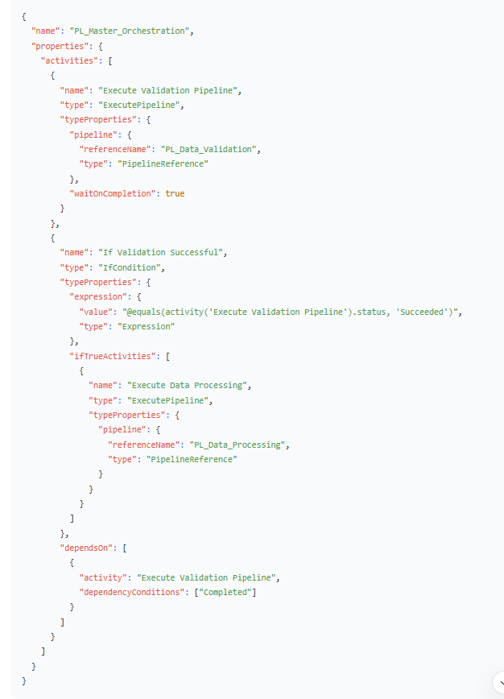

**5.2. Error Handling & Retry Mechanisms**

**5.2.1. Retry Policies**

Configured at both activity and pipeline levels:

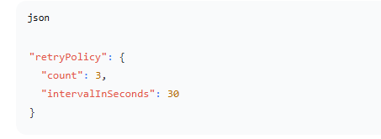

**5.2.2. Comprehensive Logging**

* All pipeline executions logged to Log Analytics workspace
* Custom logging for business-specific metrics
* Execution metadata stored in Azure SQL Database for historical analysis

**5.2.3. Alerting & Notification**

* Azure Monitor alerts configured for pipeline failures
* Email notifications via Logic Apps for critical failures
* Teams channel notifications for operational updates

**5.3. Parameterization & Configuration**

Pipelines are fully parameterized to support multiple environments and configurations:



**6. Key Features**

**6.1. Dependency Management**

* **Sequential Dependencies:** Activities execute in defined sequences
* **Conditional Dependencies:** Execution based on previous activity outcomes
* **Cross-Pipeline Dependencies:** Child pipelines execute based on parent pipeline status

**6.2. Monitoring & Observability**

* **Pipeline Run Monitoring:** Real-time tracking of pipeline executions
* **Performance Metrics:** Duration, data processed, resource utilization
* **Data Lineage:** End-to-end tracking of data movement and transformations

**6.3. Security & Compliance**

* **Managed Identity:** Service-to-service authentication
* **Role-Based Access Control:** Least privilege access principles
* **Audit Logging:** Comprehensive activity logging for compliance

**7. Testing & Validation**

**7.1. Testing Strategy**

* **Unit Testing:** Individual pipeline and activity testing
* **Integration Testing:** End-to-end workflow validation
* **Performance Testing:** Load testing with production-scale data volumes
* **Failure Testing:** Validation of error handling and recovery mechanisms